INBUILT FUNCTIONS :

DUAL :

1. POWER:

The power function to calculate the power of a number. This function takes two arguments: the base and the exponent.

Syntax: Select POWER(base,exponent) from dual;

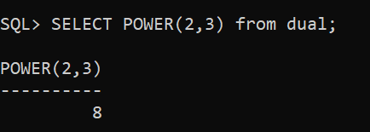Example:

1. MODE:

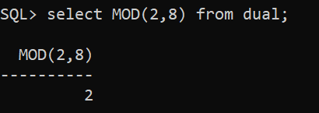

1. ABSOLUTE:

The ABS function to calculate the absolute value of a number.

Syntax: Selcet ABS(number) from dual;

Example:

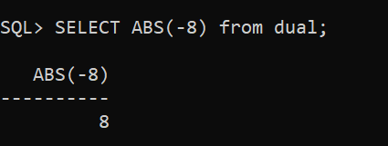

1. ROUND OFF:

Round off a number to a specified number of decimal places using the ROUND function.

Syntax: Select ROUND(number) from dual;

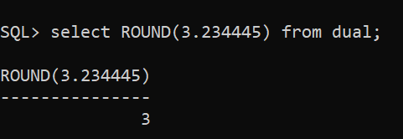Example:

1. TRUNCATE:

The TRUNC function is used to truncate a number to a specified level of precision.

Syntax: Select TRUNC(number, decimals) from dual;

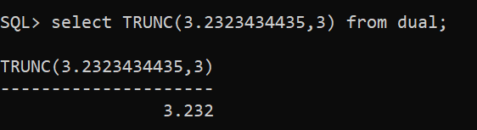Example:

1. COSINE:  
   The SIN function to calculate the cosine of an angle in radians.

Syntax: Select COS(angle) from dual;

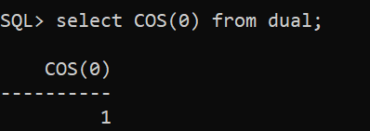Example:

1. SINE:  
   The SIN function to calculate the sine of an angle in radians.

Syntax: Select SIN(angle) from dual;

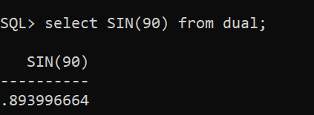Example:

1. TANGENT:  
   The SIN function to calculate the tangent of an angle in radians.

Syntax: Select TAN(angle) from dual;

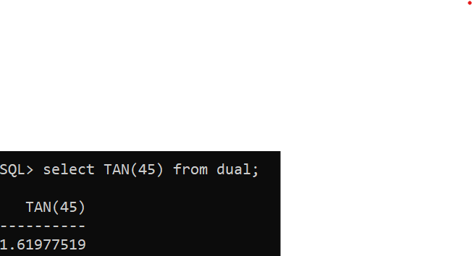Example:

1. ARCSINE:

